Date 07.04.2024

**Streamlining VPC Connectivity with AWS Transit Gateway**

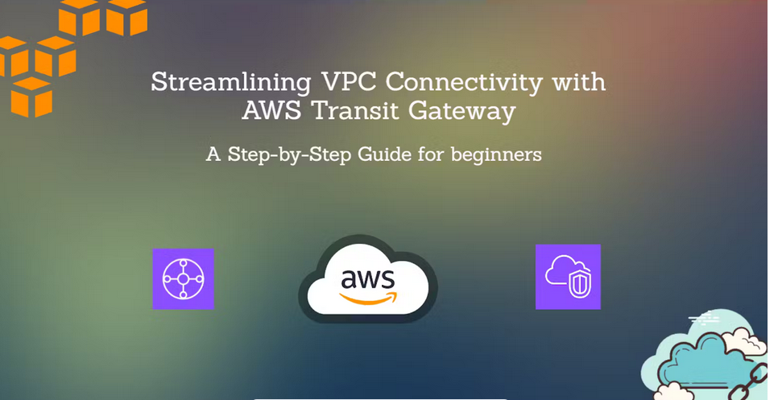

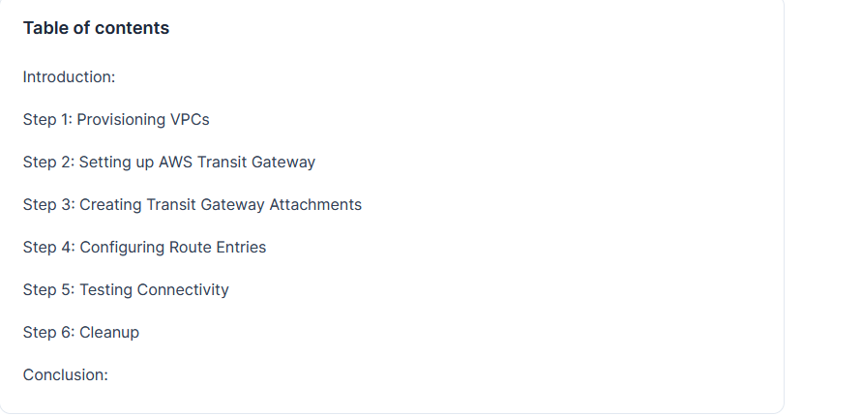

[Conclusion:](https://vamsi7894.hashnode.dev/streamlining-vpc-connectivity-with-aws-transit-gateway" \l "heading-conclusion)

**Introduction:**

Efficient networking solutions are vital for seamless communication between services and resources in cloud environments. Amazon Web Services (AWS) offers AWS Transit Gateway, a scalable and centralized solution for connecting multiple Virtual Private Clouds (VPCs) and on-premises networks. In this article, we'll explore how to set up and utilize AWS **Transit Gateway** (TGW) to establish connectivity between multiple VPCs within the same region, eliminating the time-consuming process of manually accepting peering connections.

We'll understand this in 5 steps.

Begin by creating four VPCs within any region. For this lab, I've selected London region. Ensure that each VPC has a unique CIDR block assigned to it, and also allocate a common CIDR block to all the VPCs. This setup ensures that there is no overlapping CIDR and allows for seamless communication within the VPCs.

CIDRs for each VPC:  
VPC-A - 10.0.0.0/24  
VPC-B - 10.1.0.0/24  
VPC-C - 10.2.0.0/24  
VPC-D - 10.3.0.0/24  
Common CIDR - 10.0.0.0/8

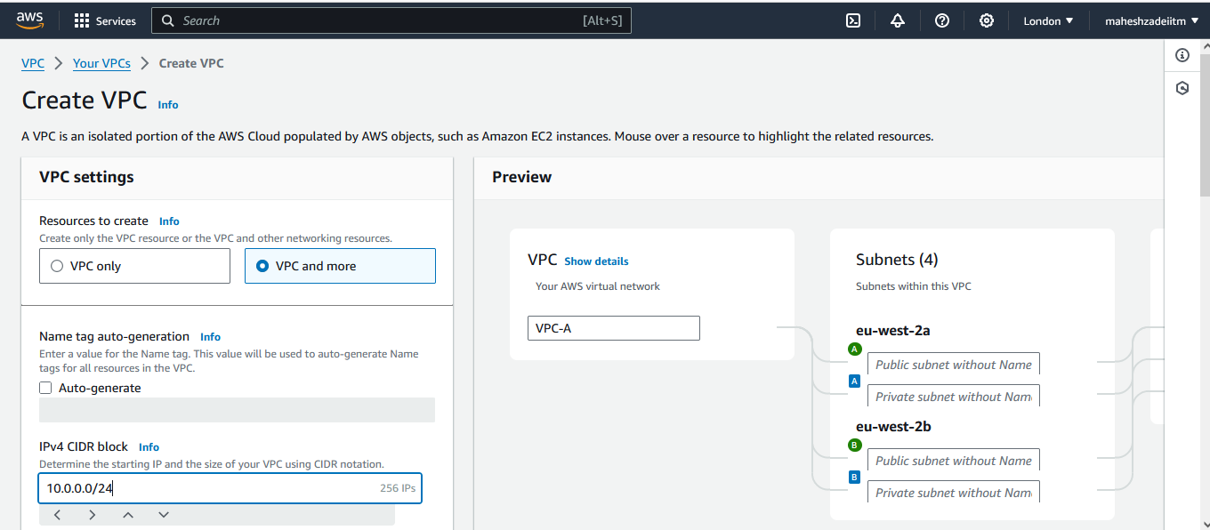

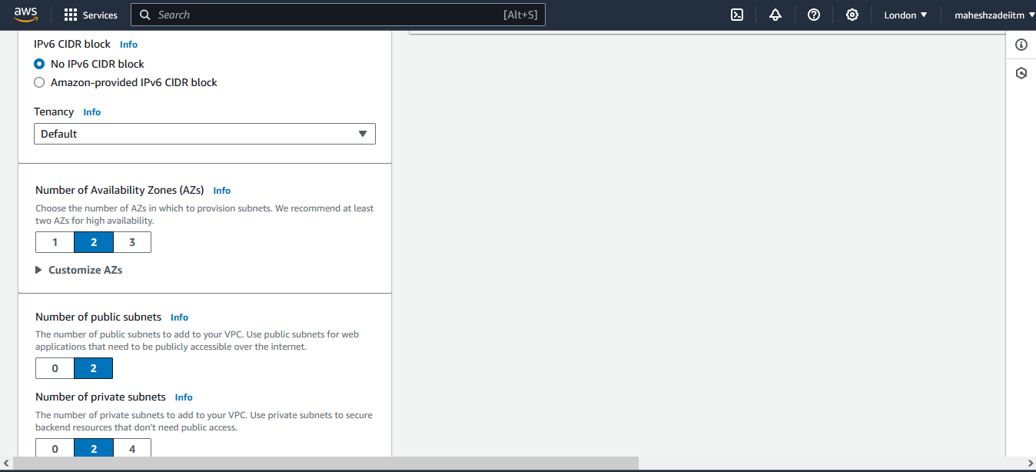

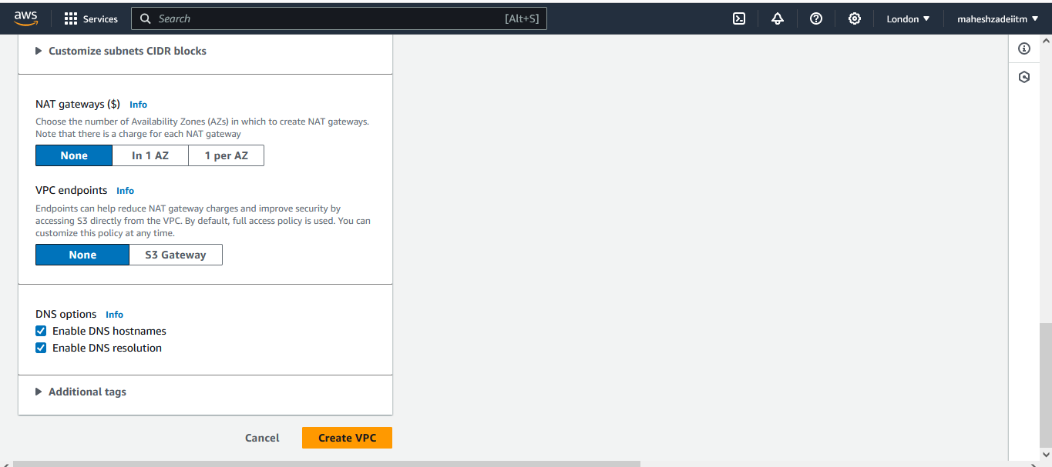

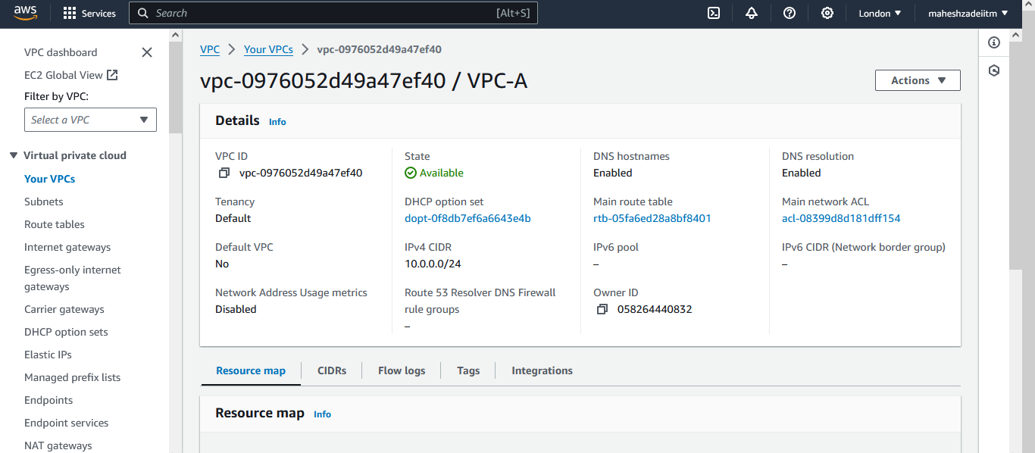

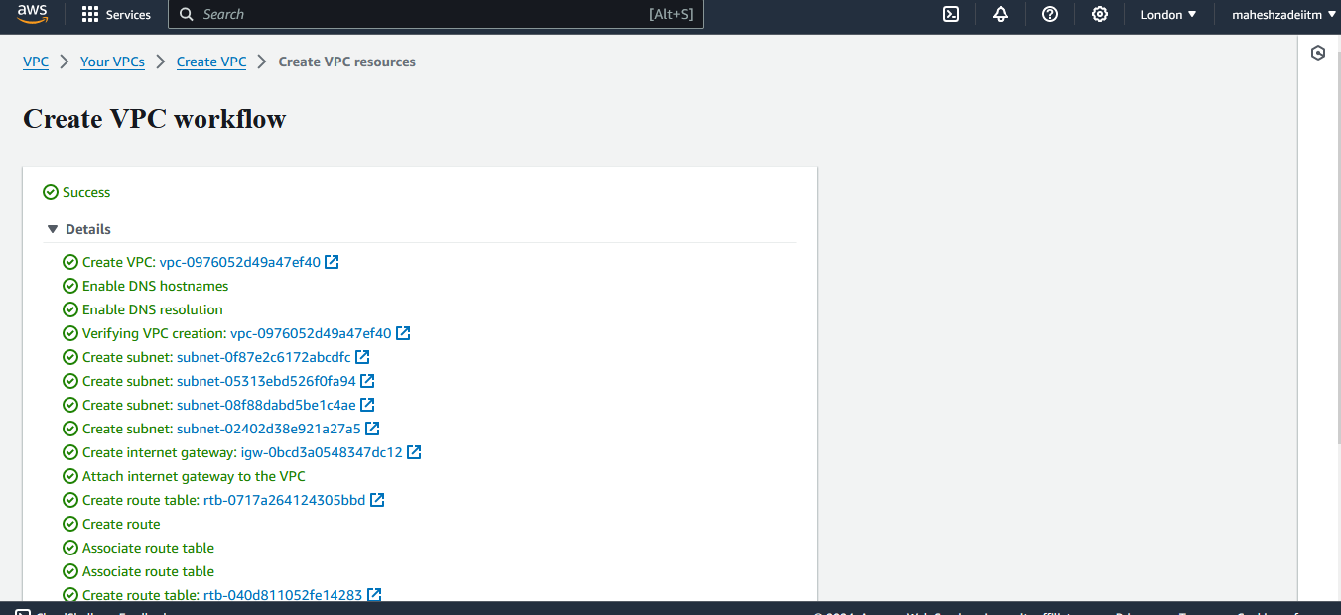

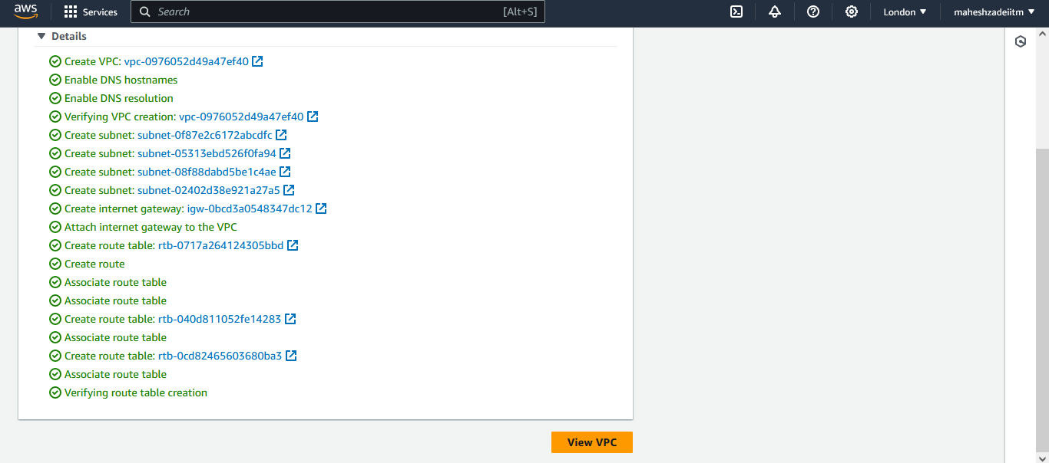

Click on Create VPC

Keep the settings as it is and Click on Create VPC. It create our first VPC (VPC-A). Similarly create the other 3.

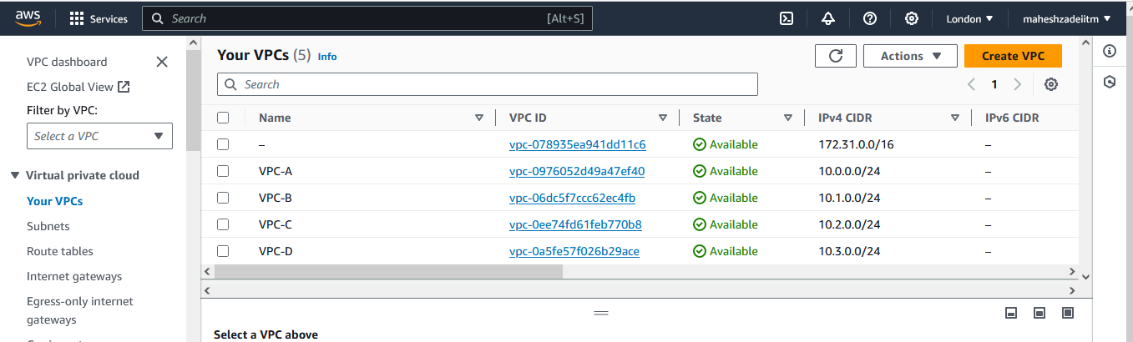

**Step 2: Setting up AWS Transit Gateway**

Next, create an AWS Transit Gateway in the London region. Provide a name and description for the Transit Gateway, and leave all other options as default. This Transit Gateway will serve as the central hub for routing traffic between the VPCs.

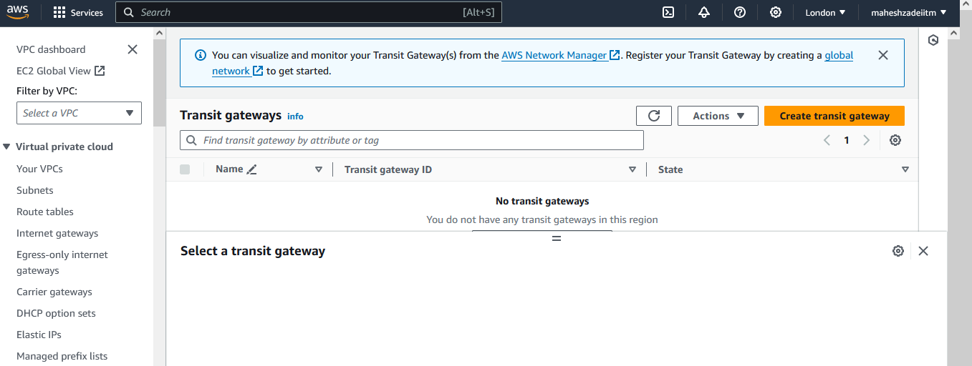

I named it as Mahesh_TGW and the same is given as Description. Keep the default settings and click on Create.

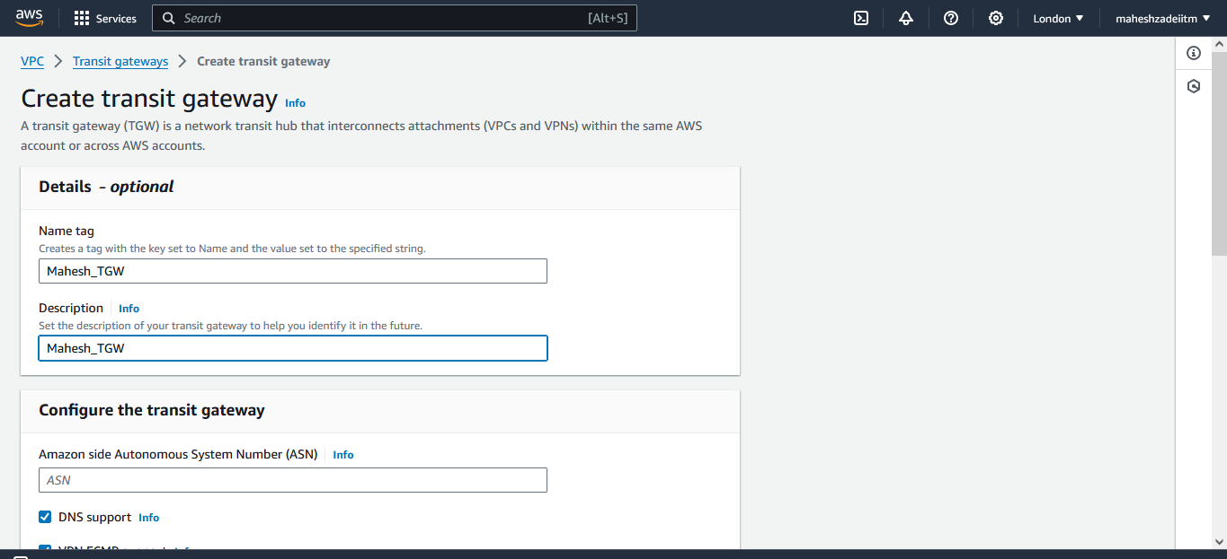

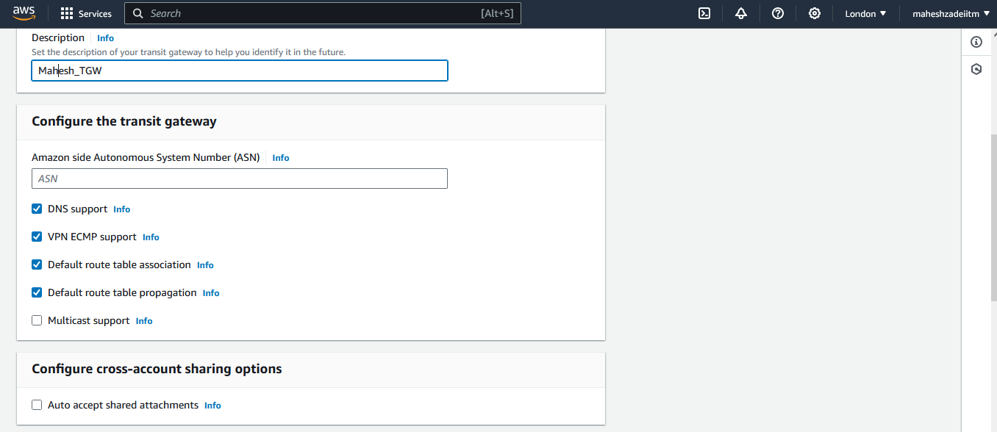

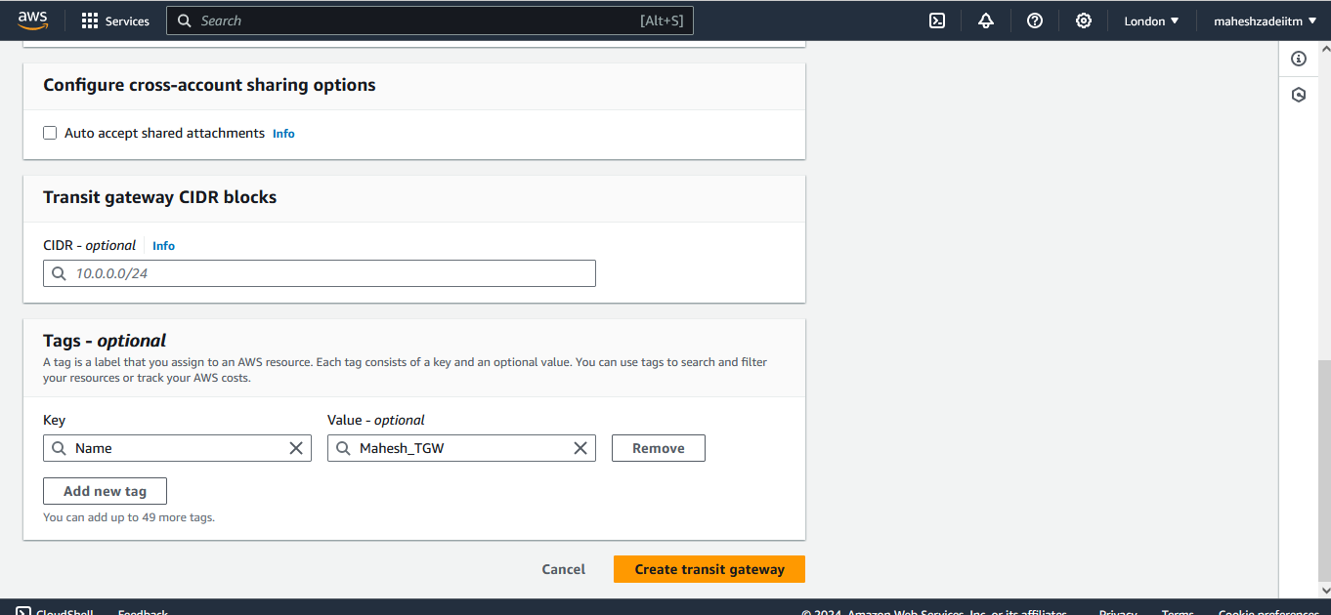

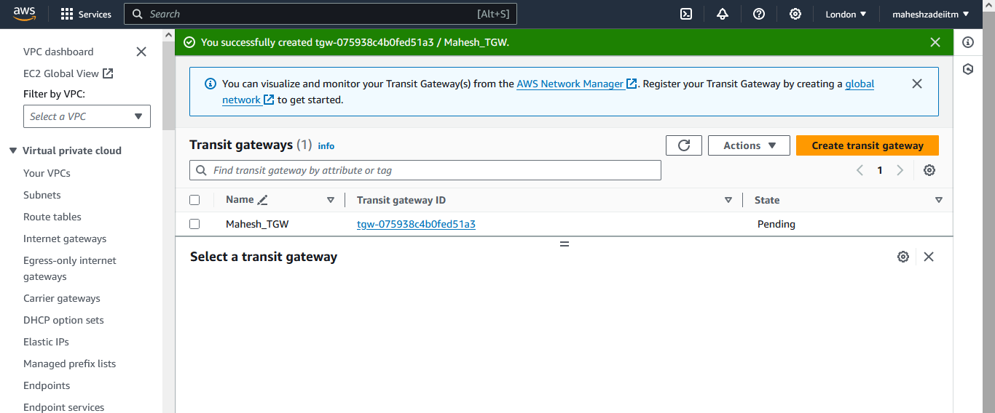

Wait still the status show Available

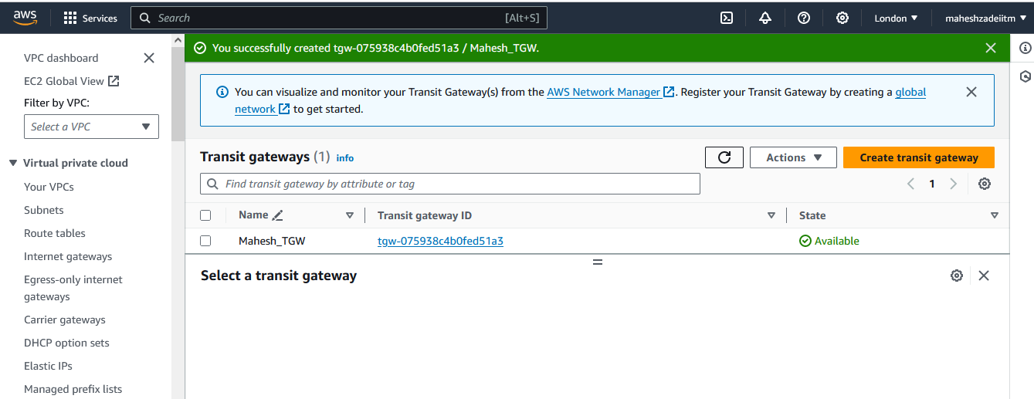

This will take some time to create the TGW.

The state is changed to Available. Now we'll go to **transit gateway attachments** and create attachments.

**Step 3: Creating Transit Gateway Attachments**

Once the TGW is set up, create TGW attachments for each VPC. Specify the TGW ID and choose the attachment type as "VPC." Select the respective VPC and subnets for each attachment. This establishes the connectivity between the TGW and the VPCs.

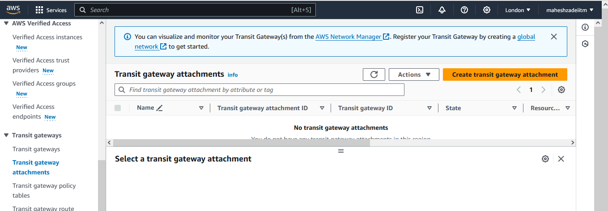

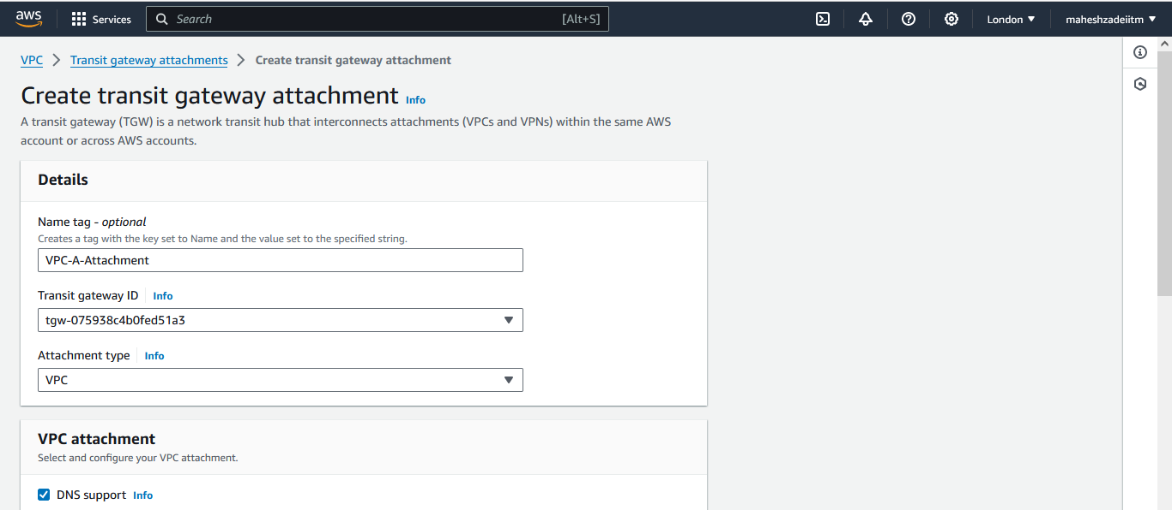

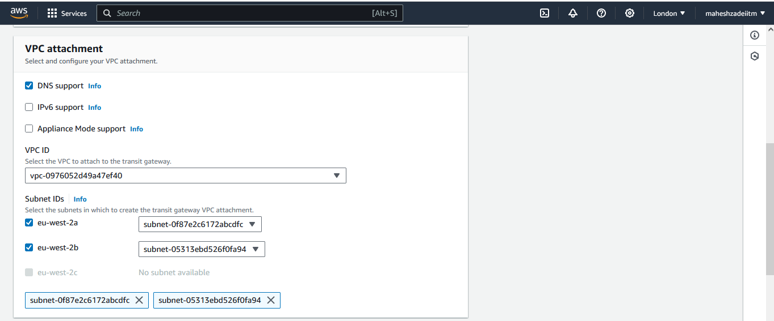

We've to carefully do this step, I chose, VPC-A. then we need to select the 2 subnets of explicit association. In my case one subnet is ending with dfc and another with a94

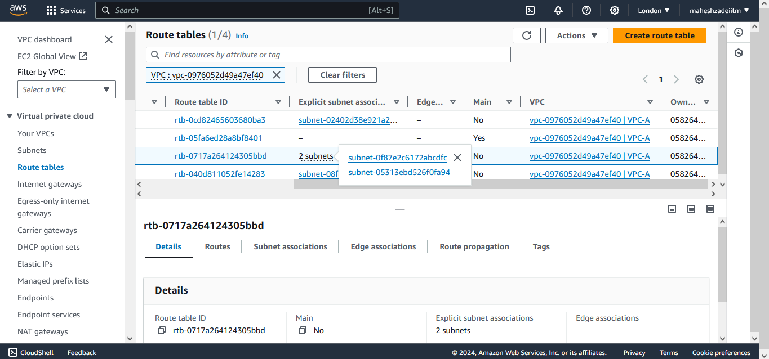

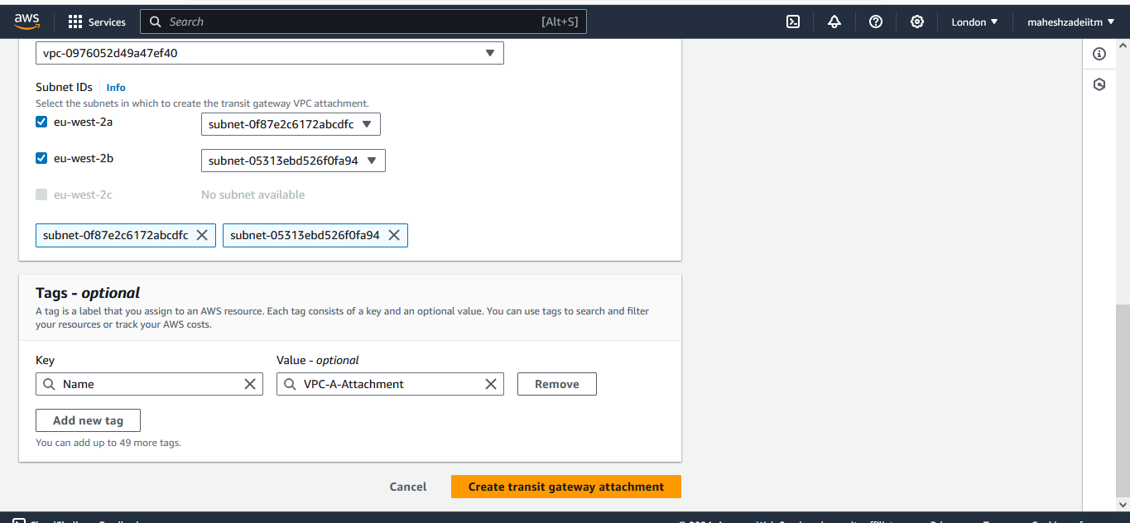

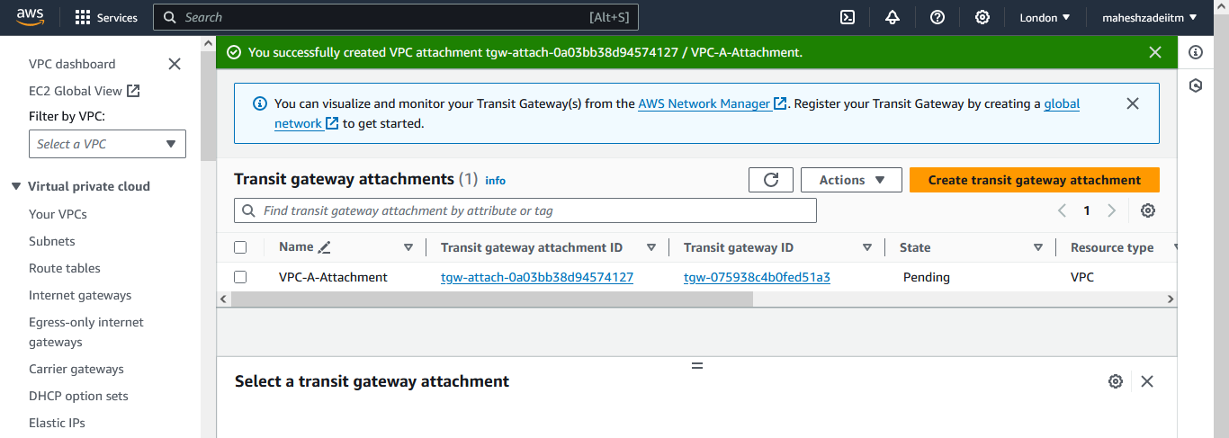

Similarly do association for the other VPCs.

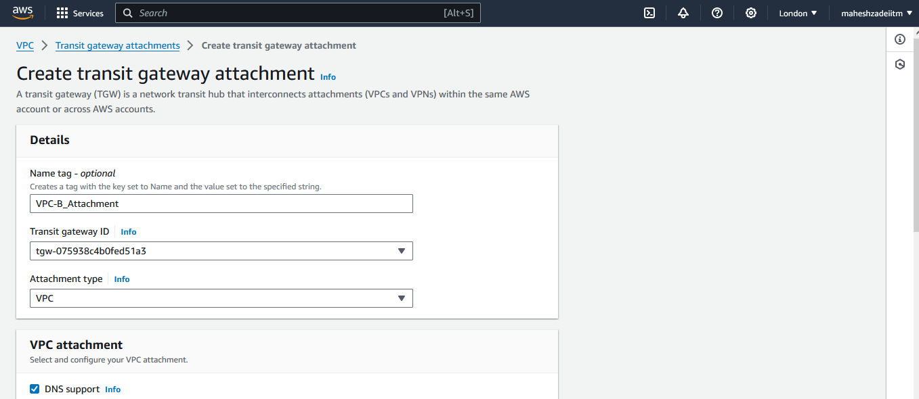

Check the Subnet in Route Table Correctly

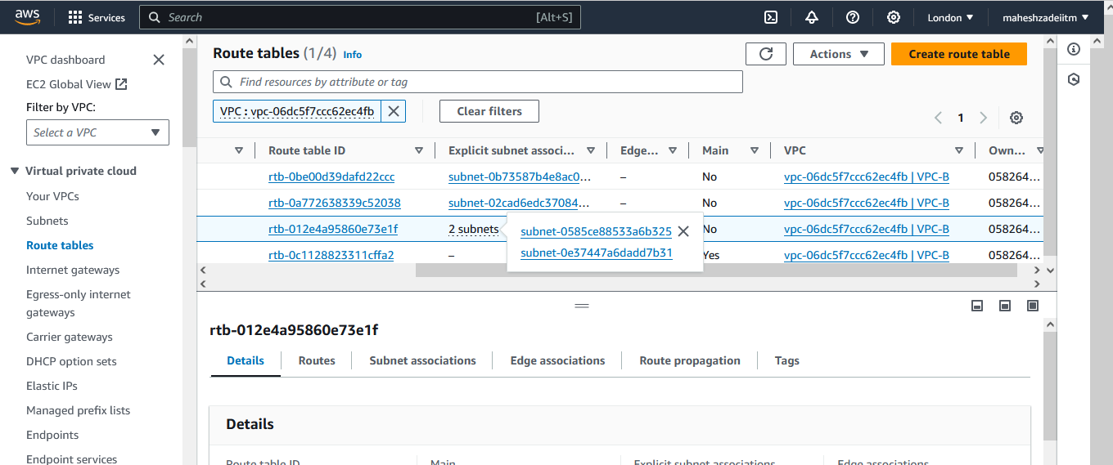

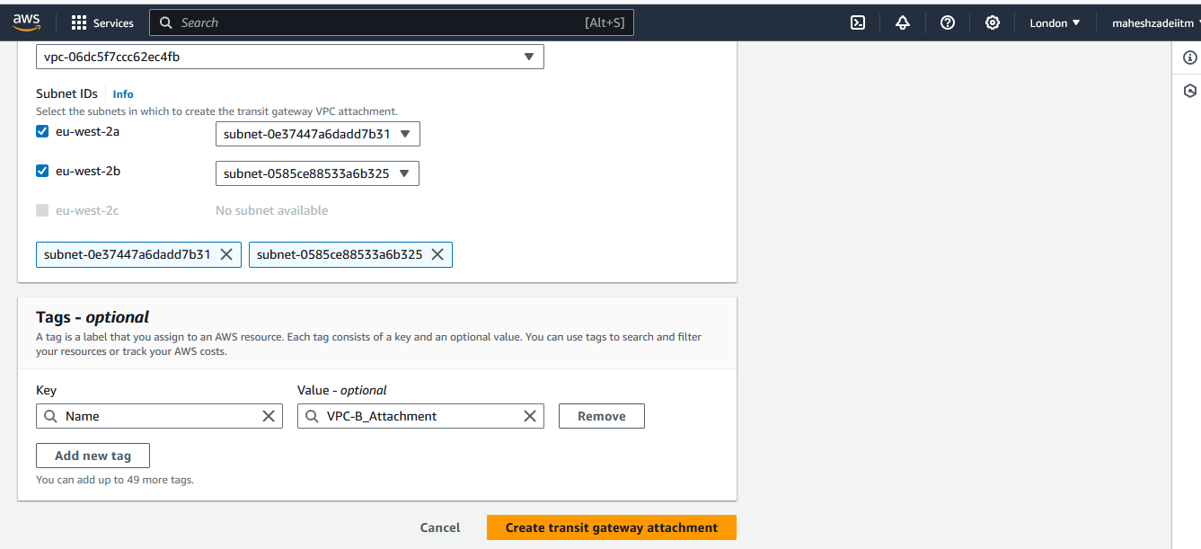

We've to carefully do this step, I chose, VPC-B. then we need to select the 2 subnets of explicit association. In my case one subnet ends with b31 and another with 326.

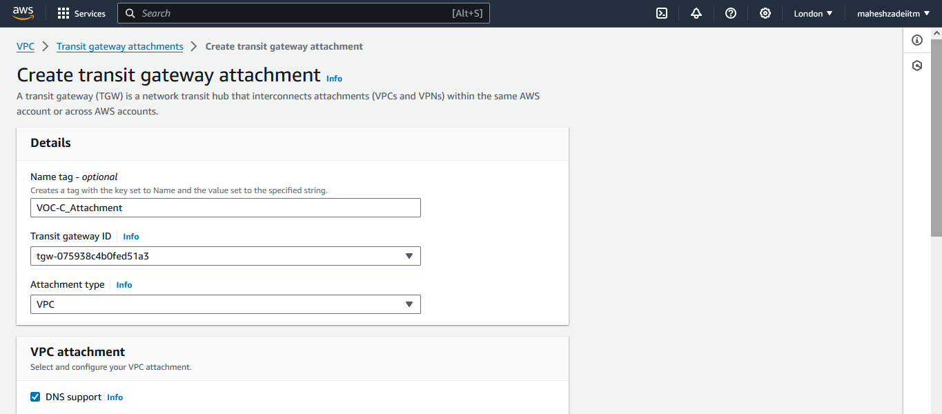

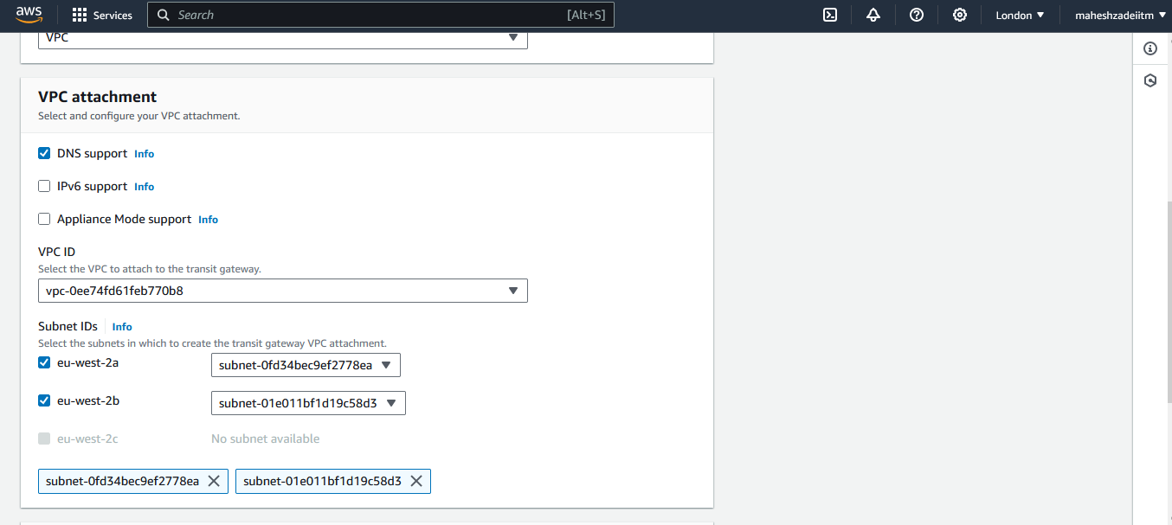

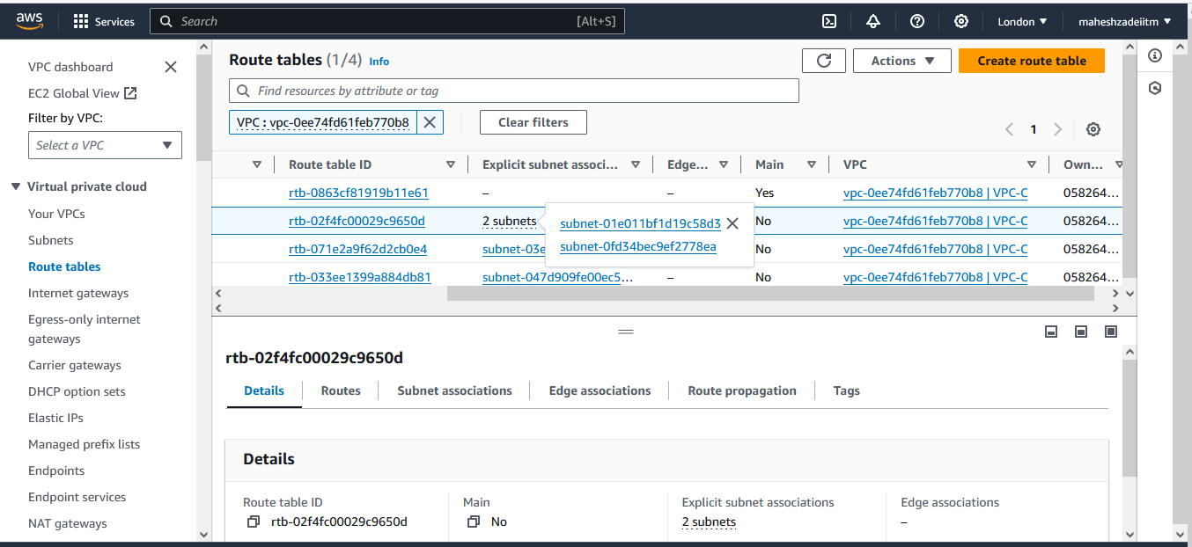

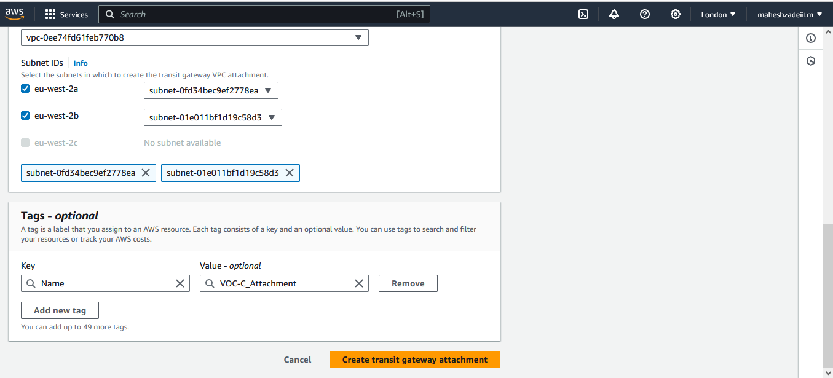

We've to carefully do this step, I chose, VPC-C. then we need to select the 2 subnets of explicit association. In my case one subnet is ending with 8d3 and another with 8ea

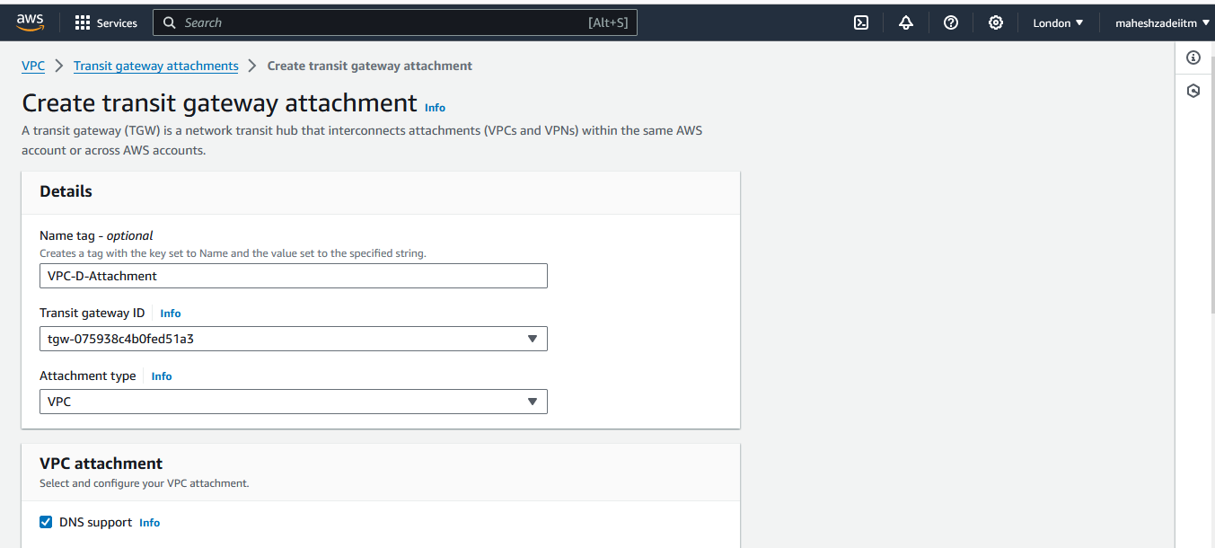

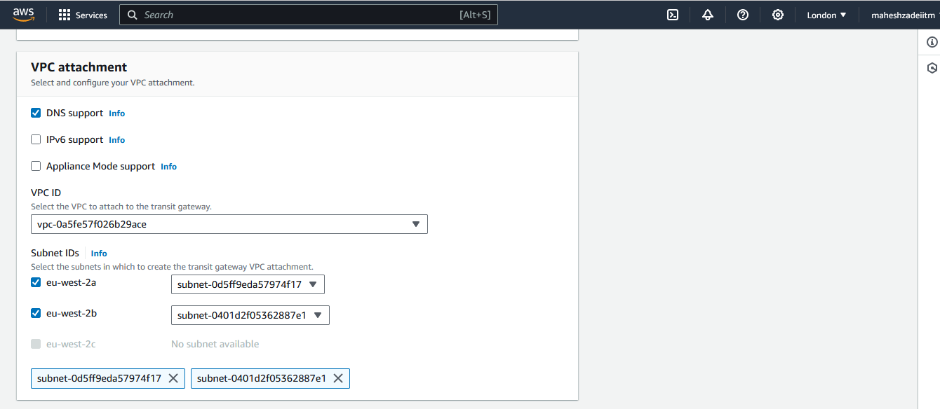

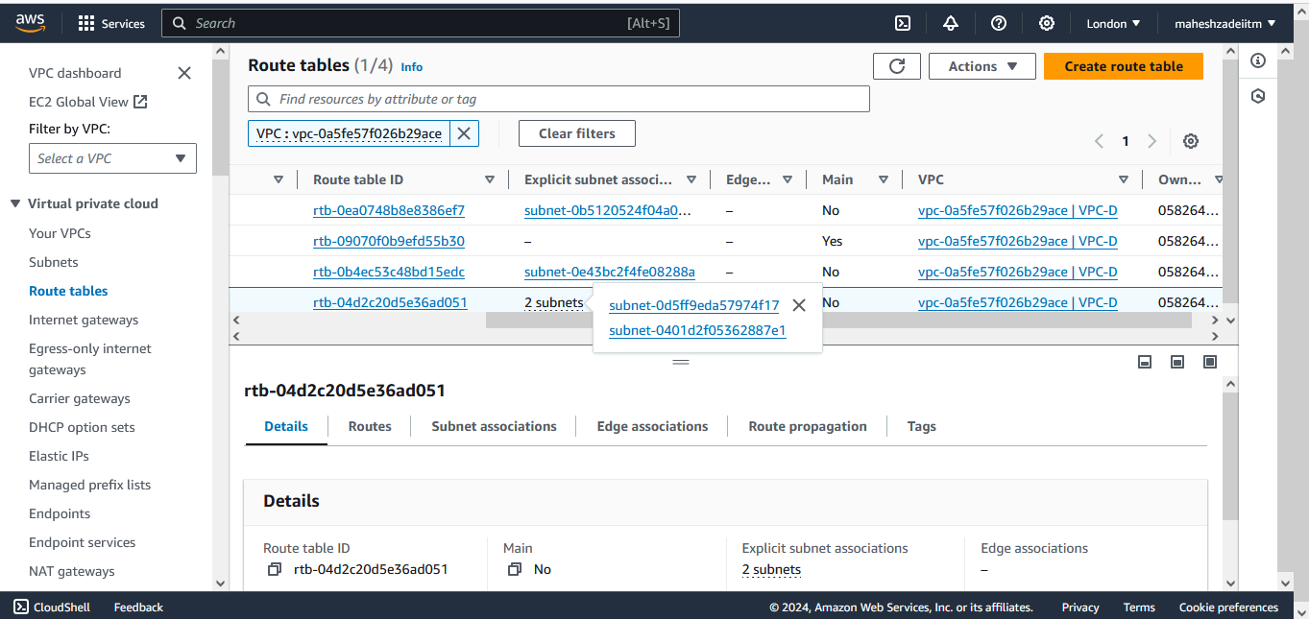

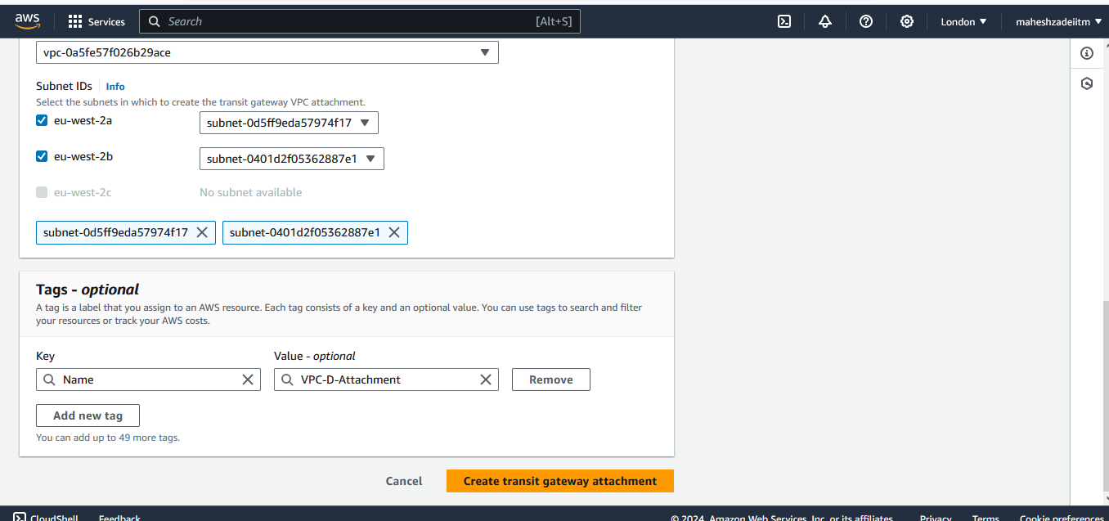

We've to carefully do this step, I chose, VPC-D. then we need to select the 2 subnets of explicit association. In my case one subnet is ending with f17 and another with 7e1..

Now all 4 transit gateway attachment completed.

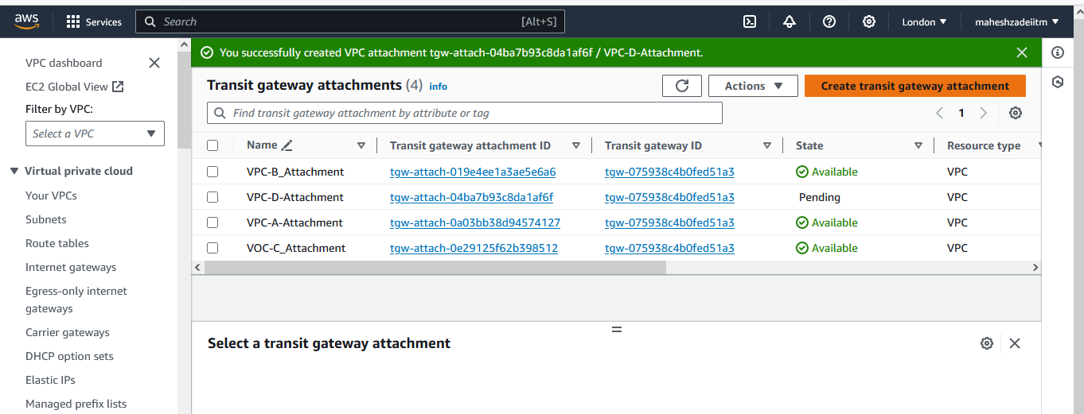

Wait until the state for all the attachments is changed to **Available**. Meanwhile, configure the route entries.

**Step 4: Configuring Route Entries**

Now, configure route entries in the route tables associated with the VPC subnets. Add a route entry for the common CIDR block (10.0.0.0/8) with the TGW as the target. This ensures that traffic destined for the common CIDR block is routed through the TGW.

We'll now go to Route Tables, and select those Route Tables where there are 2 explicit subnet associations are present as shown below.

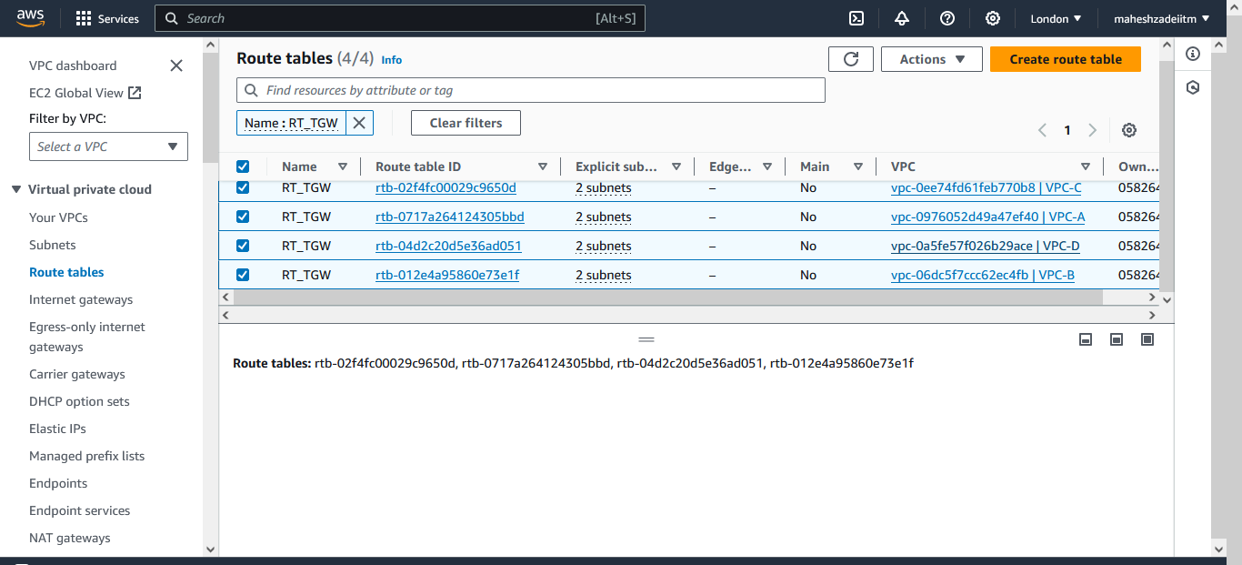

I've renamed them as RT for TGW. For each of this RT, we've to add a route to the TGW to route the traffic.

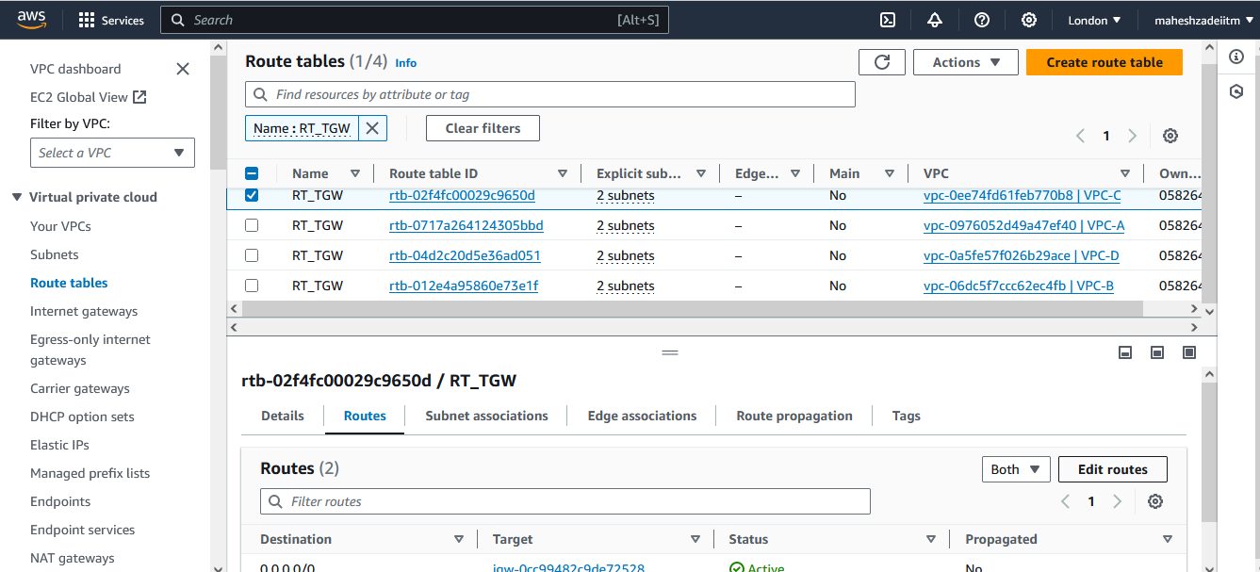

Go to Edit Route

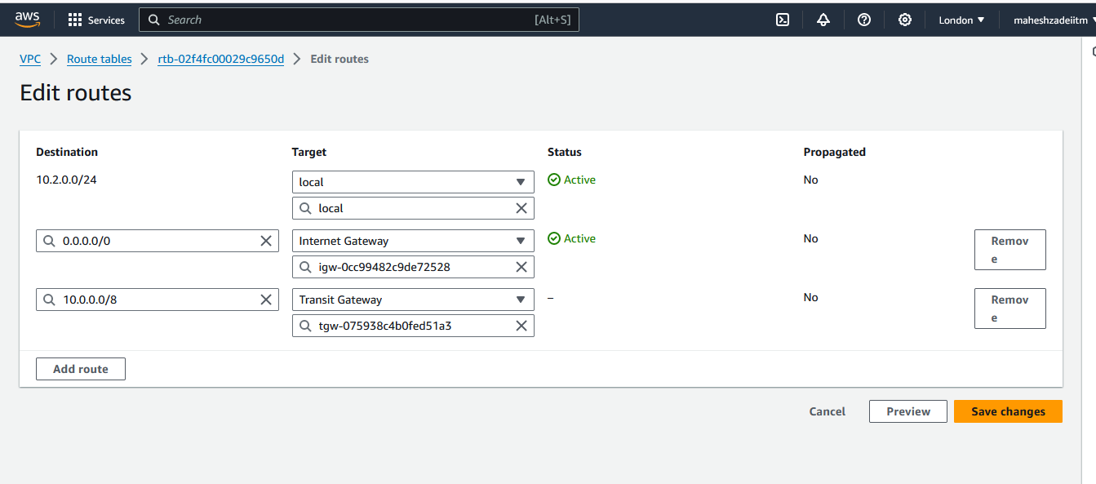

I've renamed them as RT for TGW. For each of this RT, we've to add a route to the TGW to route the traffic.

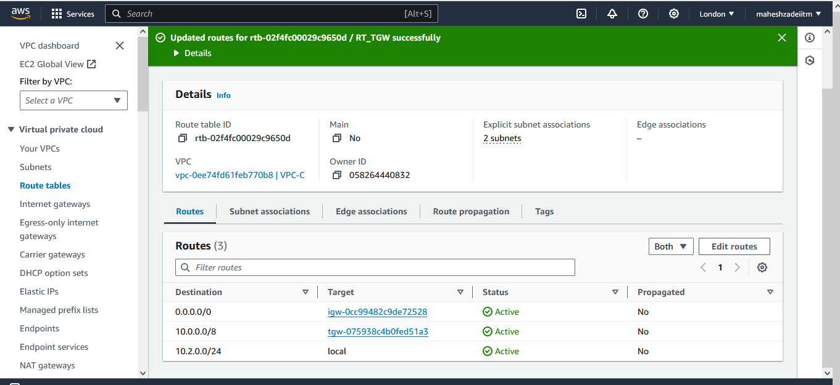

Route is added. Similarly, repeat this process for the remaining 3 RTs.

**Step 5: Testing Connectivity**

To test the setup, launch EC2 instances in two different VPCs. Ensure that the instances are launched in subnets associated with the route tables containing the Transit Gateway route entry. Attempt to communicate between the EC2 instances using their private IP addresses. For this test purpose, I'll create a Windows EC2 instance in VPC-A and an Amazon Linux EC2 in VPC-B. Let's test this.

Launch EC2 in VPC-A

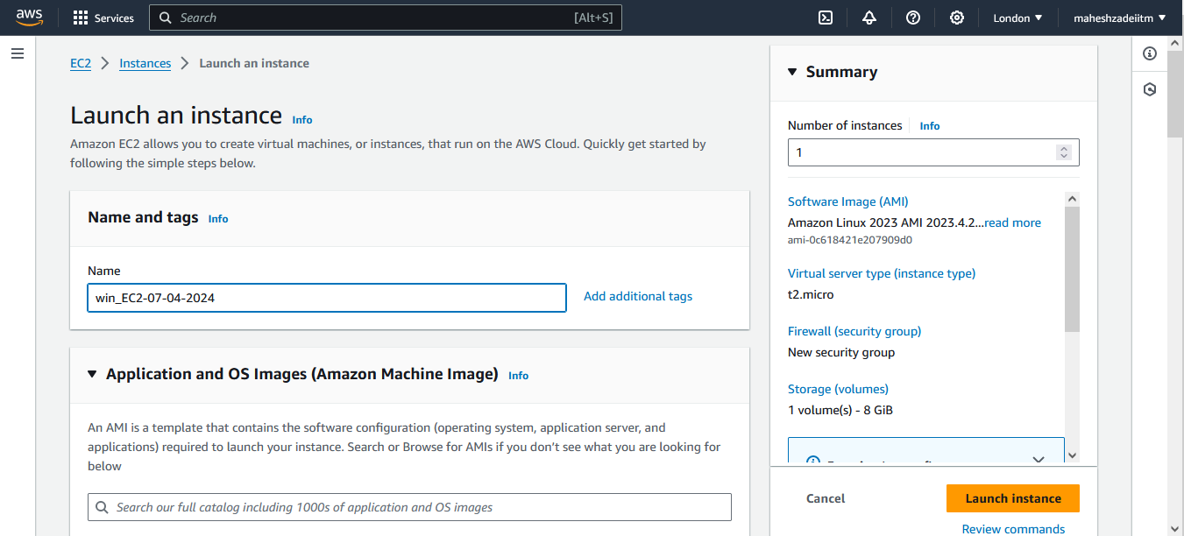

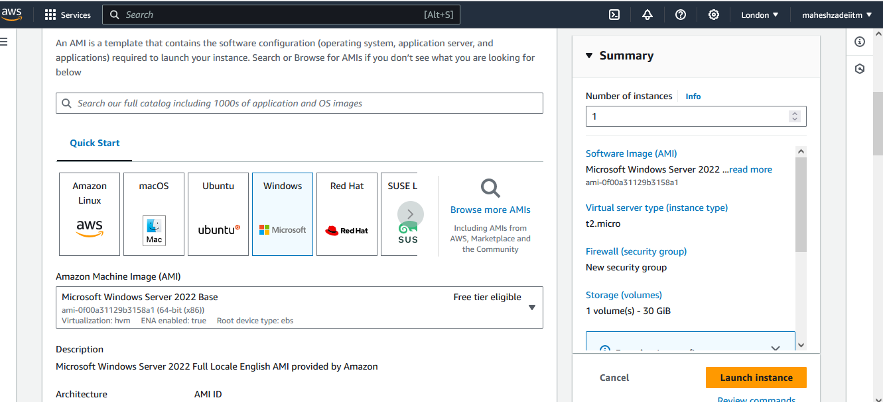

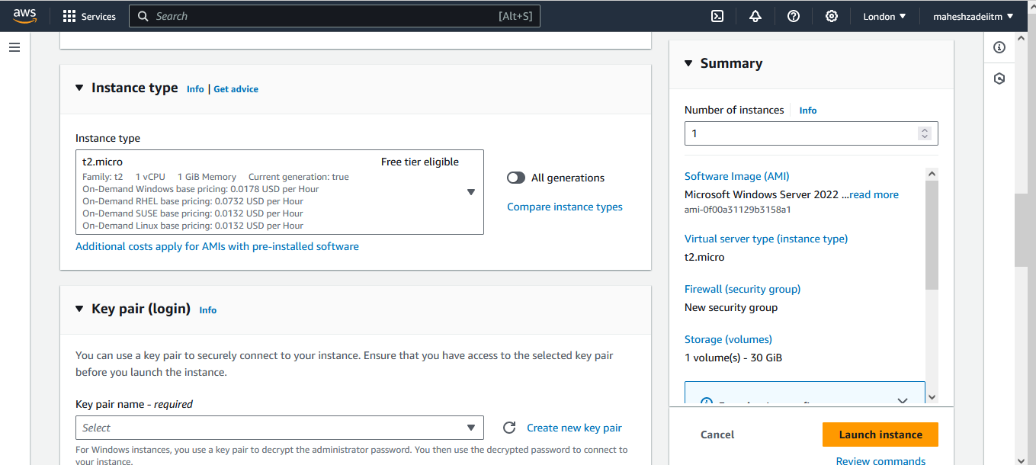

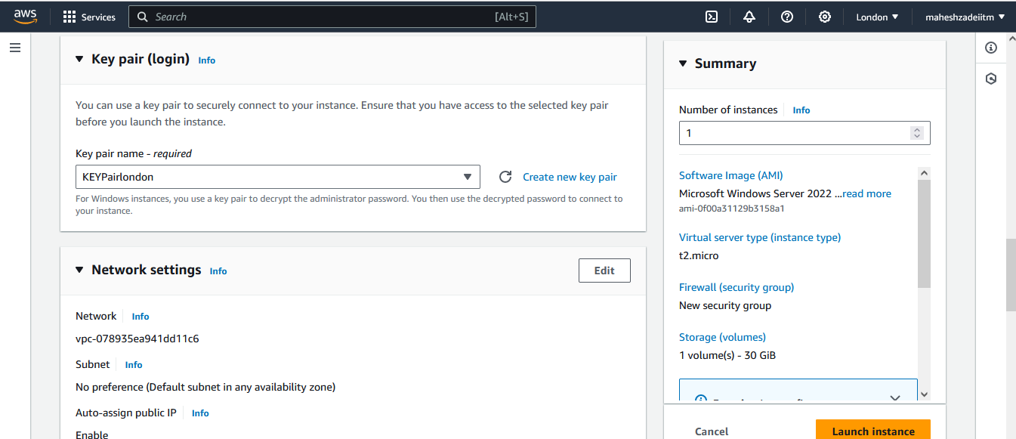

Edit Network Setting and Choose the VPC , Subnet and Auto Assigned the Public IP

Choose the Correct subnet as shown for VPC A in Route Table.

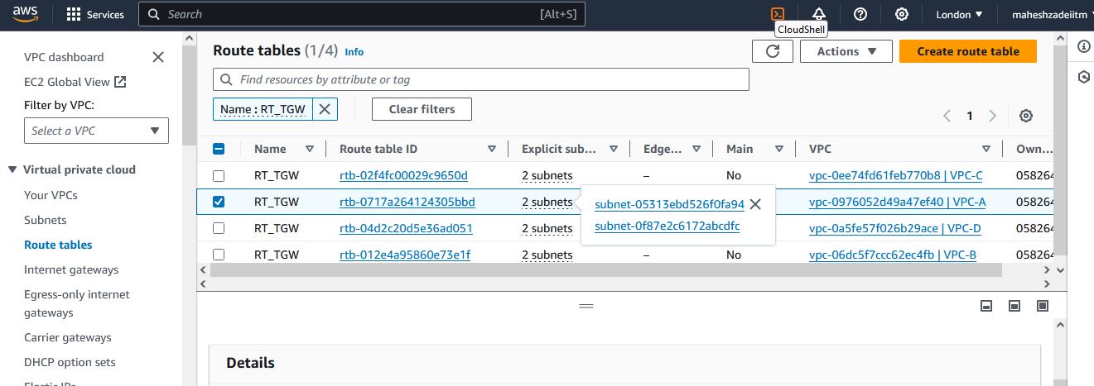

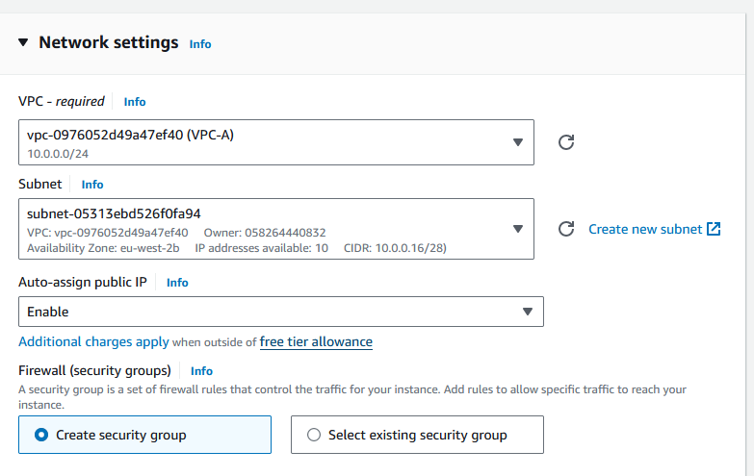

Default Security Group

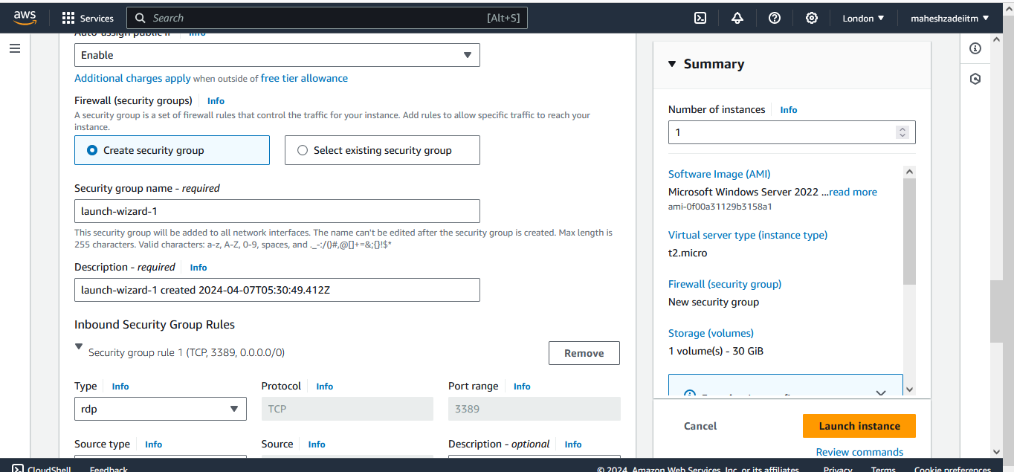

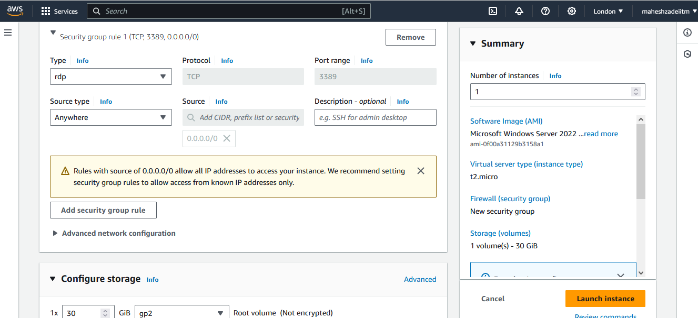

Click on Launch instance.

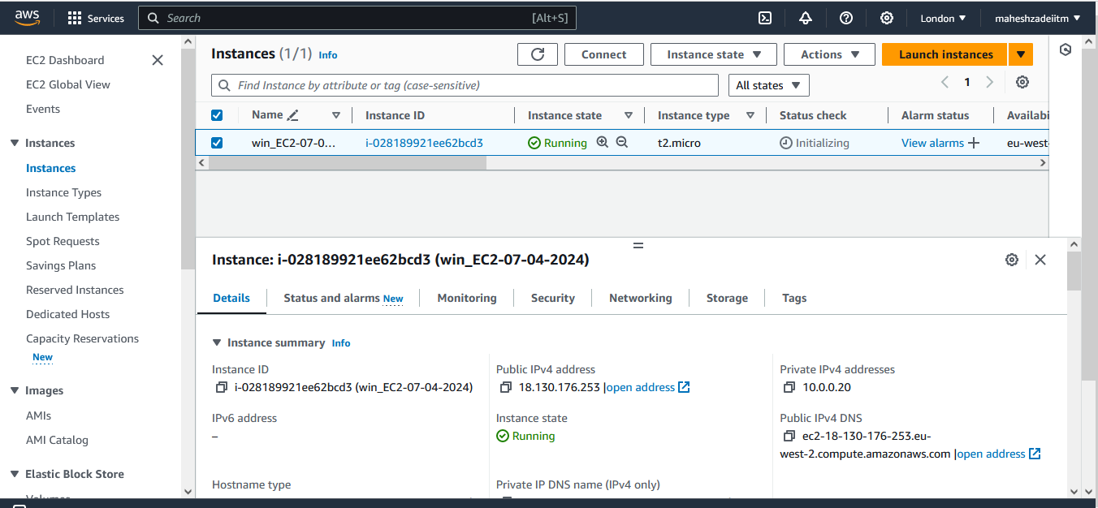

Now Click on Connect

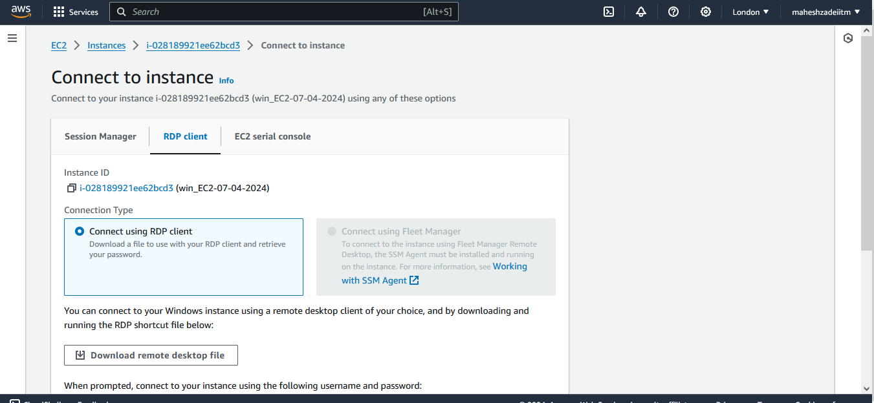

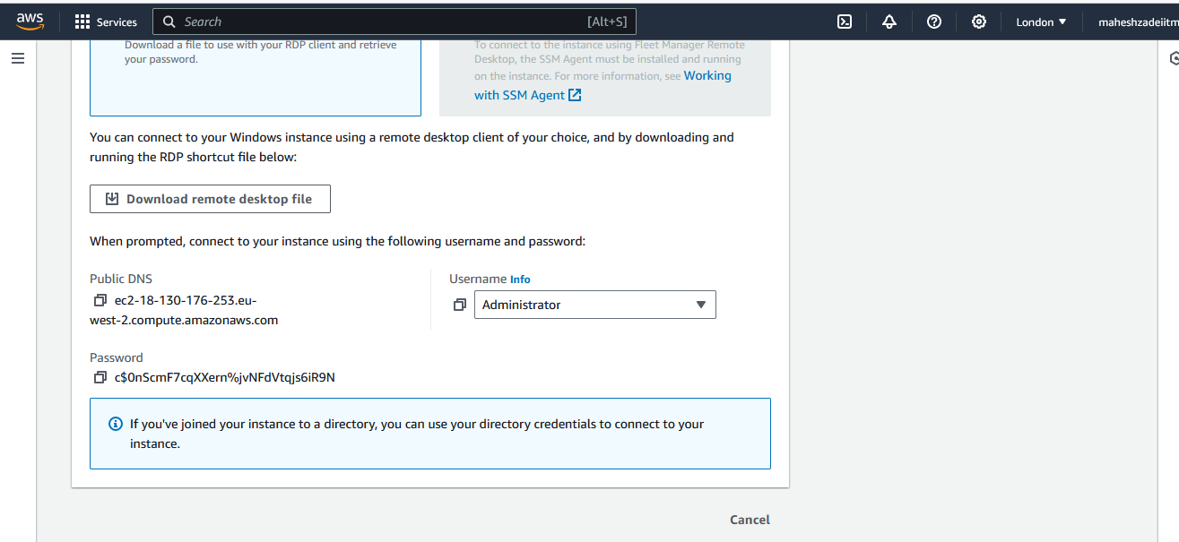

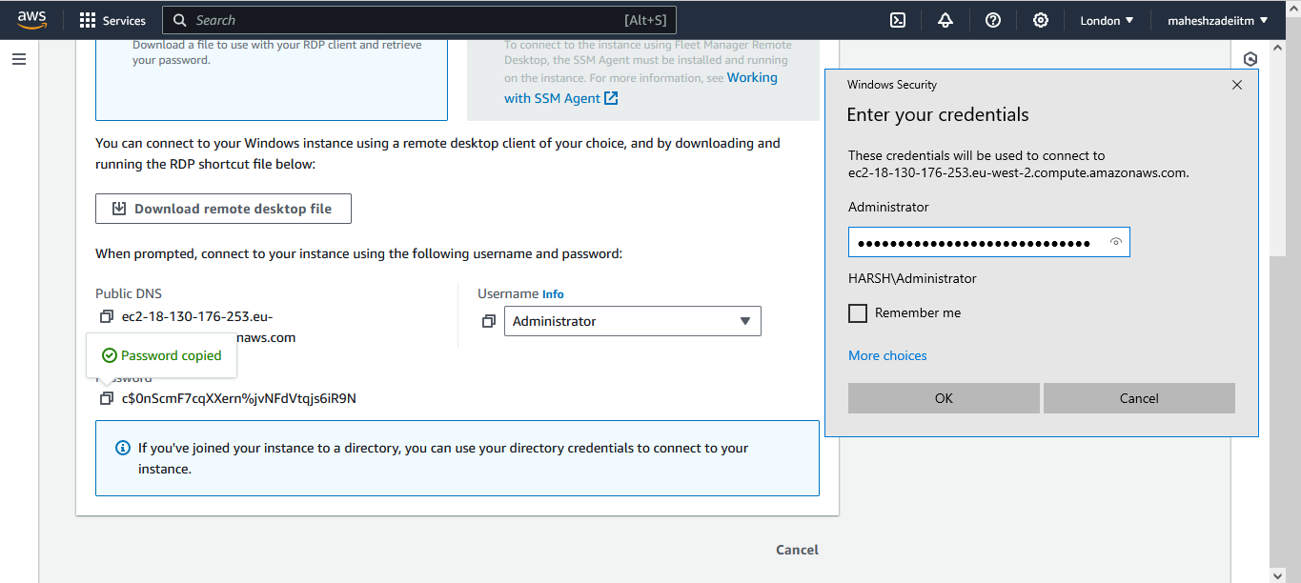

Copy the Keypair and Mobaxtert of London in EC2-Windows Machine for Linux machine Connectivity in VPC-B EC2 Instance

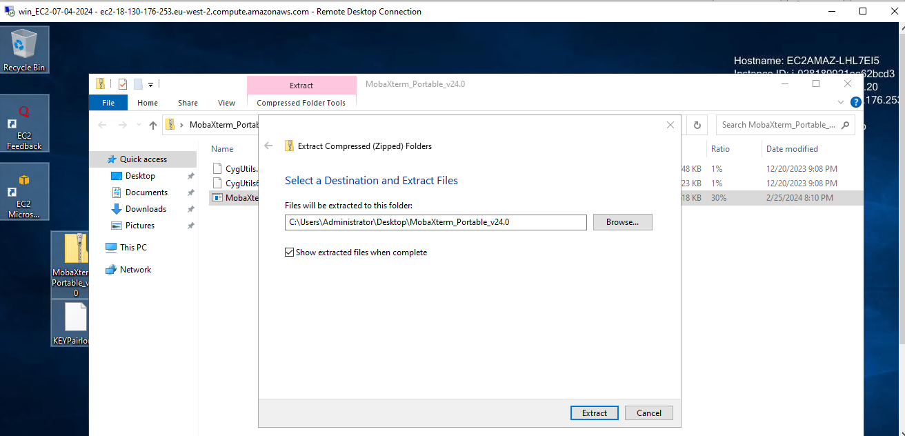

Launch EC2-Linux in VPC-B

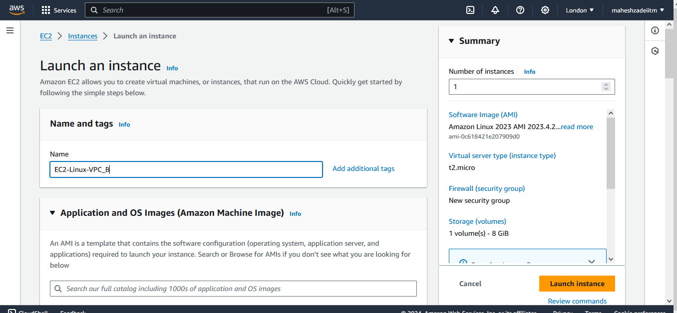

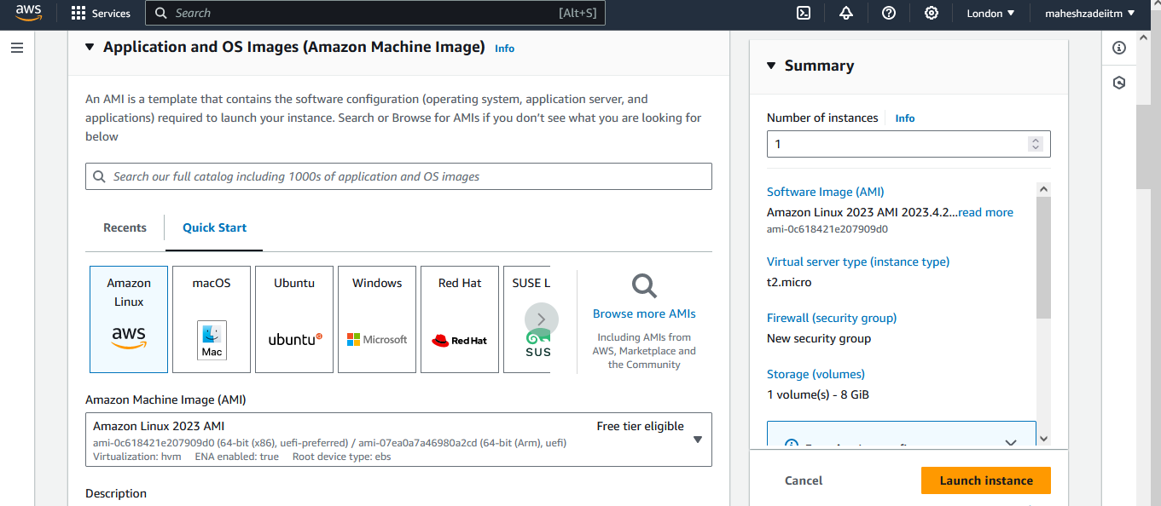

Go to Network Setting

Choose the VPC-B Subnet as pe the RT shown and disable the Auto assigned public IP

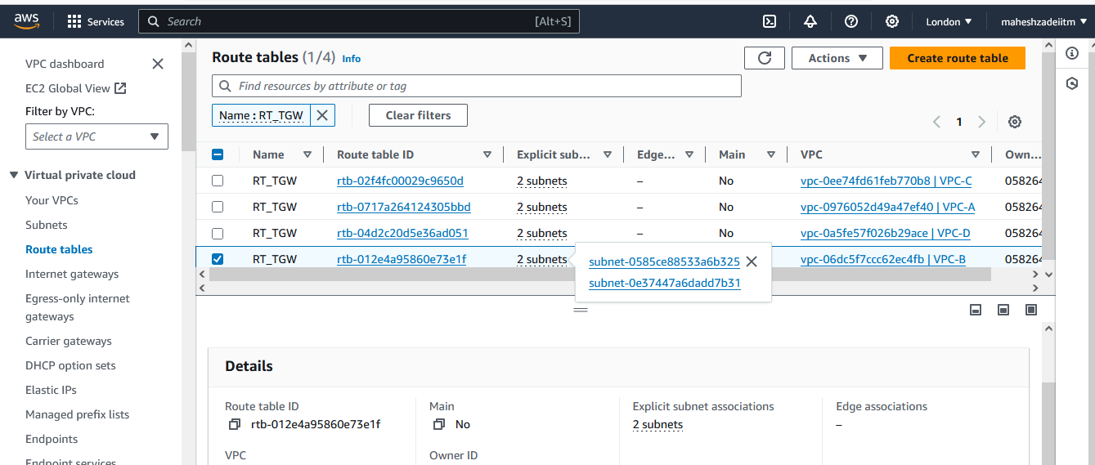

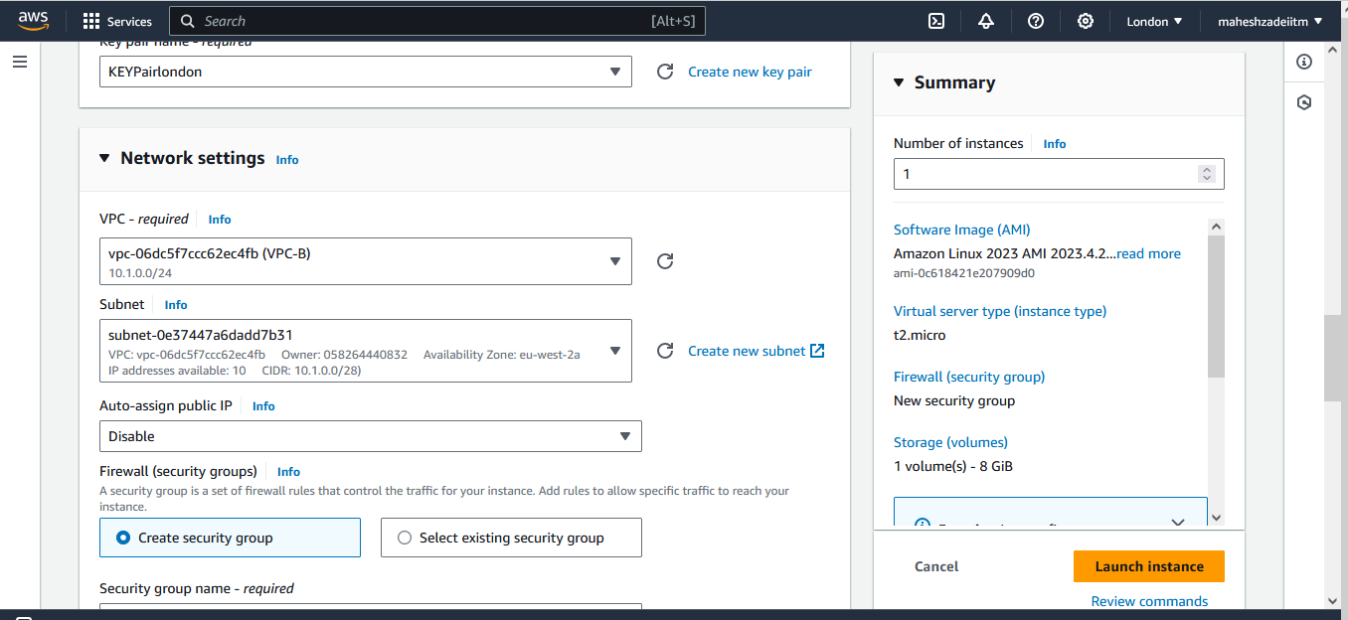

Click on Launch Instance

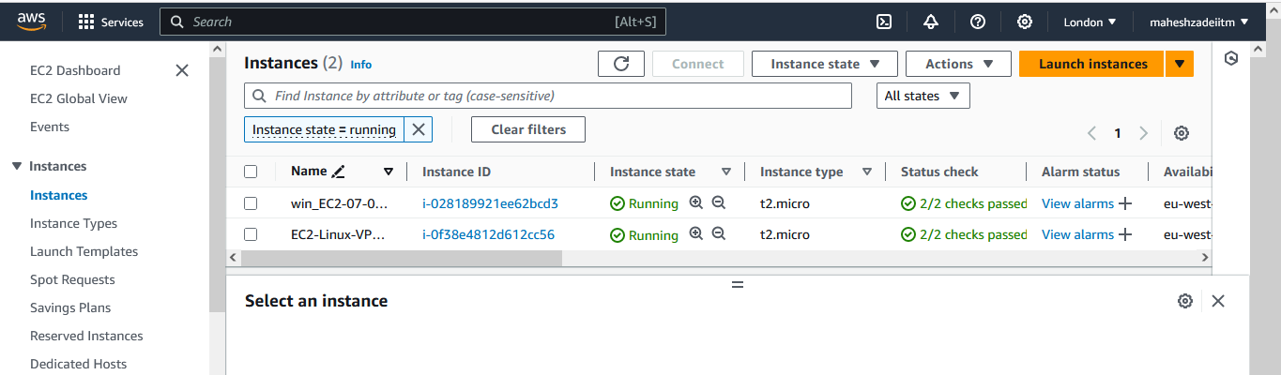

First let's connect to Windows EC2 using RDP. From Windows, we'll connect to Linux via SSH using MobaXterm

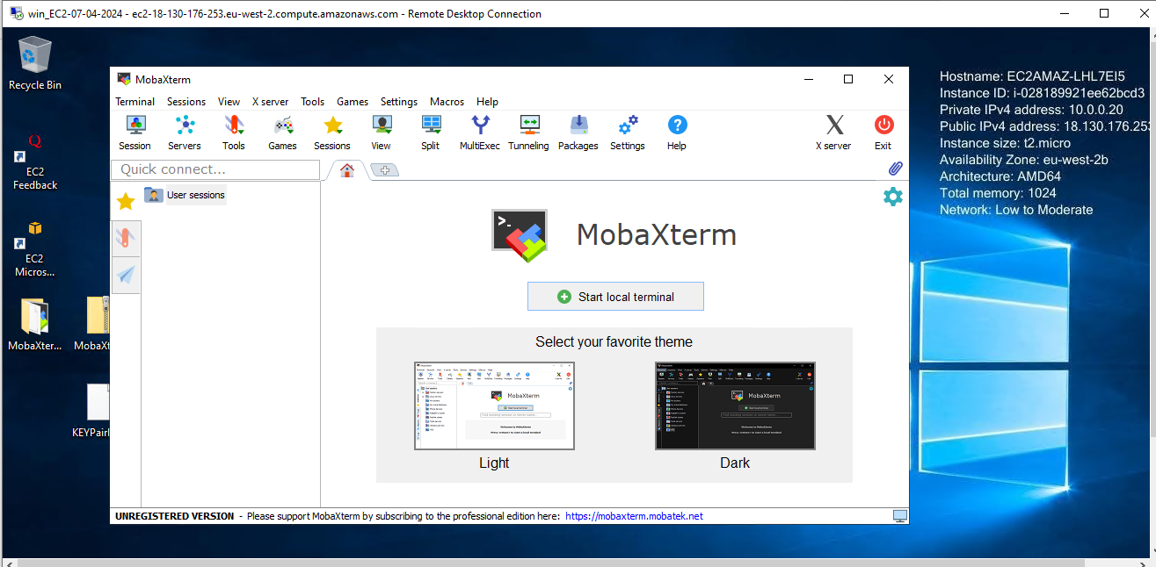

Copy the private IP of the Linux EC2 Instance .

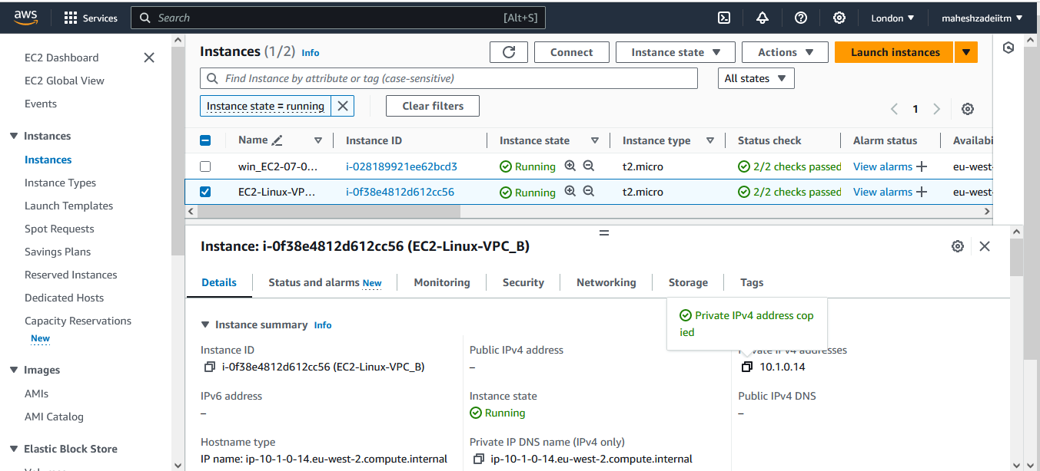

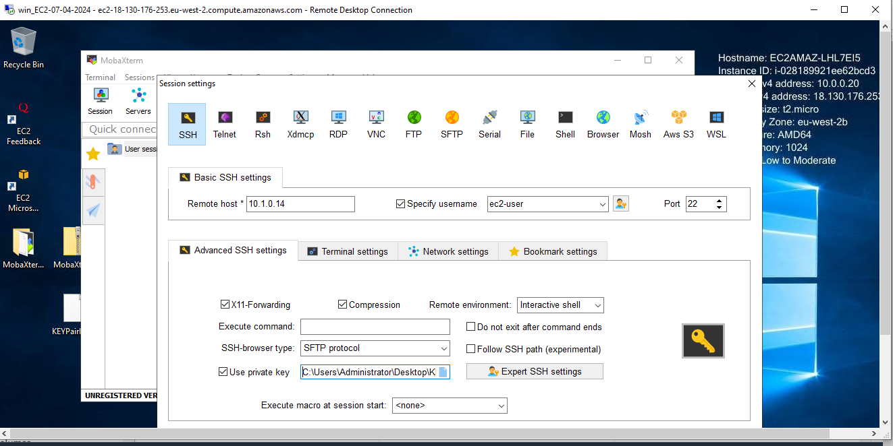

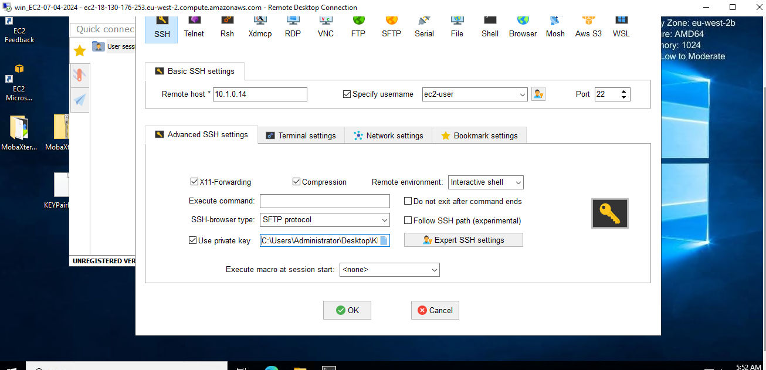

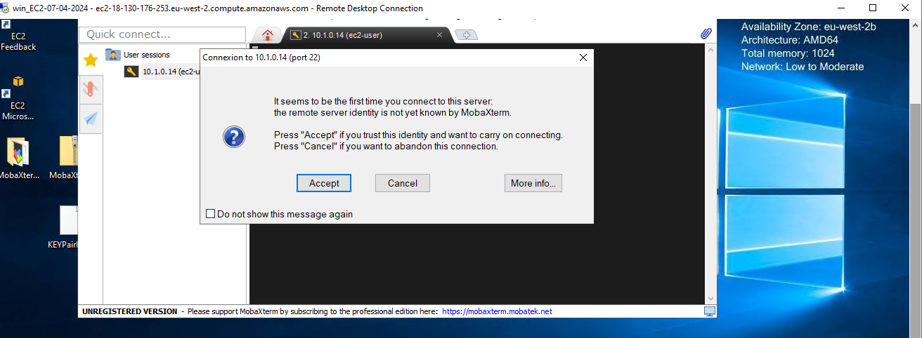

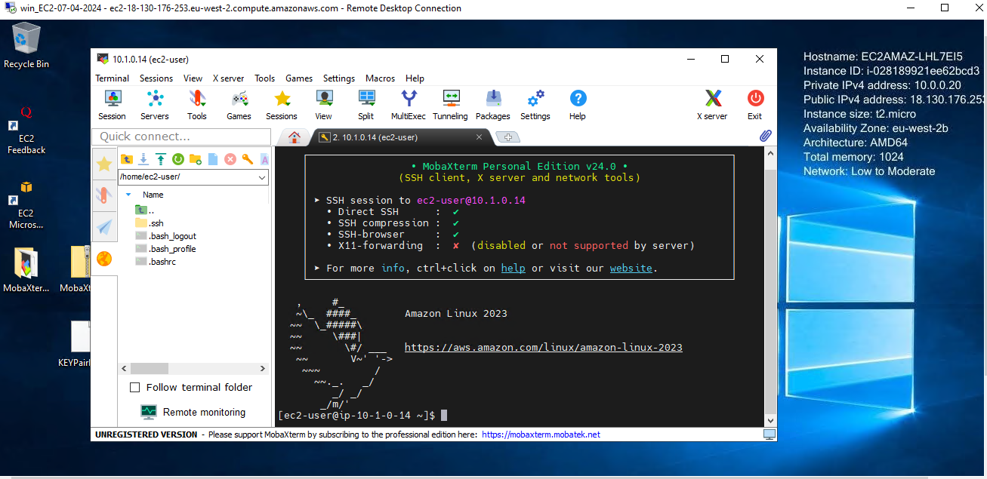

Successful communication indicates that the Transit Gateway is functioning correctly.  
This communication is no longer possible, If we delete the TGW.

**Step 6: Cleanup**

After testing, clean up the resources in the following order  
1. Delete the Transit Gateway attachments,  
2. Delete the Transit Gateway, and  
3. Delete the routes explicitly added in the RTs.

Verify that connectivity is disrupted after cleanup, ensuring that resources are no longer accessible across VPCs. Finally, Terminate the EC2 instances.

**Conclusion:**

AWS Transit Gateway offers a scalable and efficient solution for interconnecting multiple VPCs within the same region. By following the steps outlined in this article, users can establish a robust network architecture that enables seamless communication between VPCs while maintaining security and scalability. Embracing AWS Transit Gateway empowers organizations to streamline their networking infrastructure and drive innovation in the cloud computing space.

Thanks

Mahesh Zade